CAREER EPISODE 2

INTRODUCTION:
Time duration
Location
Organization
Project
Position
Project Supervisor
Project submitted to
This career episode is about my project named “Design fabricate and test truncated micro strip antenna for GPS”. This project was carried out and submitted during final year as course requirement in Electronic and Communication Engineering in ________ from ……………..to ………………

CE 2.1
The project was done during the graduate course in Electronic and Communication Engineering in _____________________. The project was carried individually under the supervision of antenna wave and propagation professor as semester project.

BACKGROUND:

CE 2.2
This project was completed in the final year of my bachelor degree program, during my final year I learned the basics of antenna and about their working this got me interested so I decided to make my own truncated antenna and test this antenna in university lab for result. I discuss this with my course professor and he agreed and asked to test antenna various parameters like VSWR, reflection coefficient, impedance and output gain.

CE 2.3
This project aim was to identify and report the process for antenna design for specific frequency and how it is tested to that frequency to check its output. The whole project was separated in different parts,
- Selection of material and defining parameters for antenna magus.
- Simulating this design in feko to get real life results.
- Fabrication of antenna
- Testing of antenna with analyzer

CE 2.4
This project is completely design by myself and for guidance I refer to my course professor,

Fig: Organisational Structure

CE 2.5
As antennas are of various types and I couldn’t make every type of antenna so I dediced to choose a particular type and study its paramaters. And I choose microstrip antenna for this project because its low efiency and bandwidth because of the presence of dielectrice between ground plate and patch. The matrial which I used for my antenna is FR4 Pcb (flame retardant grade 4) and this material have permittivity and low tangent loss, so it is ideal for my project as bandwidth and efficeincy can be increased with high value of permittivity. Also micro strip antennas are easy to manfacture and have low cost for construction and this was major factor in choosing this type of antenna as I could easliy fabricate it myself.
PERSONAL ENGINEERING ACTIVITY
CE 2.6
As project owner I had to study, research and test the antenna on various factors mention below
- Bandwidth
- VSWR
- Reflection coefficient
- Output gain
The range of frequency on which antenna works is called bandwidth and can be measued simply by
Bandwidth = ($fu-fl)/fc*100$
VWSR (variable standing wave ratio) is measures to check how well RF (radio frequency) are being transmitted from source to transmission line or antenna.
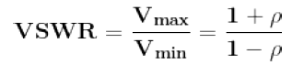
Reflection coefficient is know as the reflection of waves caused by irregular impedance.
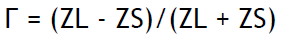
Gain is how much power is being conveted into waves and are being transmitted.

CE 2.7
Designing a truncated microstrip antenna was a challege itself in the project and for this purpose I used FR4 material with thickness of 1.5mm. the materail relativity permitivitty is 4.3 and tangent loss is 0.03. perceived. During designing of antenna I assumed that gain of antenna is very low because it has low tangent loss which factor to the materail I used. To overcome this problem several modification were made in design and the antenna was truncated from two corner. The frequency which will be transmited from antenna is set at 1575.5MHz. The resonant length of truncated microstrip antenna is calculated by,
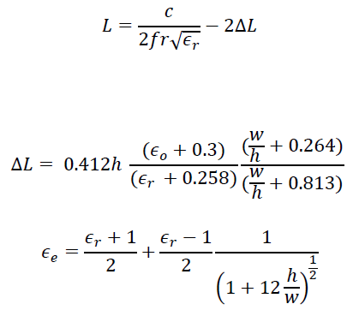
In Formula ΔL is the patch length at each cornoer. H is the the substance thickness. ε_{r} and ε_{e} are relative constant. W is the width of patch.
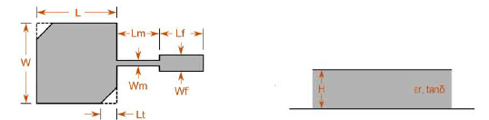
Top View Side View

CE 2.8
After designing antenna, its performance was measued by using antenna Magus. It is a software which helped me checked the parameter like impedance, reflection coeffiecnt, and VSWR. For this operating frequency 1575.5Mhz, Dielectric constant according to FR4 is 4.3 Height of substrate 1.5mm and loss tangent 0.03 is given with length of antenna in Magus and following graph were obtained,
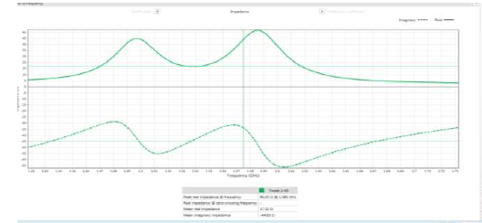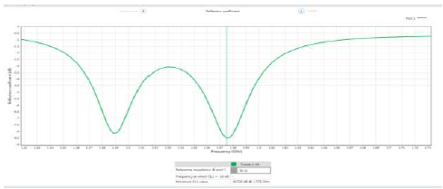
Impedance Reflection coefficient
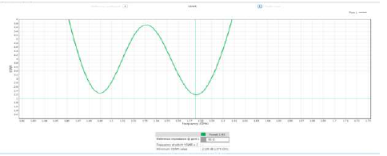
VSWR < 2.5
By Using Magus it helped me matched the feed line and width according to antenna’s impedance. If I placed the feed line closer to the antenna edge the impedance decreases. By this technique I was able to design feed line for my antenna.
CE 2.9
For modification in geometry of antenna I had to used Feko software as magus cannot do that. Therfore the I imported the design in feko which was created in magus to analyse 3D pattern geometry and gain of antenna.
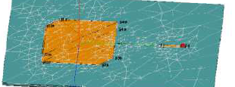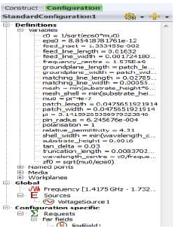
After all the design specification were entered in Feko I generted the polar graph which showed that antenna is transmitting in one direction and the gain is very low 0.07db.
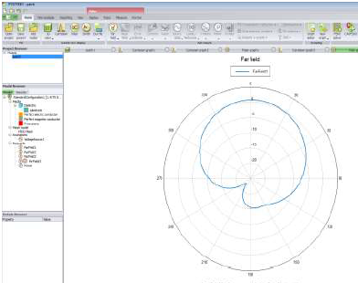
After testing of antenna on feko the antenna was fabricated using FR4 material which I got from my university lab. And this was then fabricated on Fiber PCB board for antenna feed SMA connector was soldered on the rear of board.
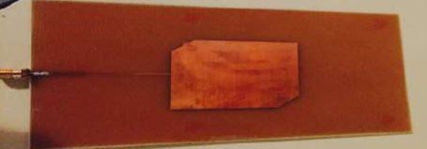
I used SMA connector because it could be easily attached to the network analyser which I got from university lab.
CE 2.10
Using network analyzer I was able to perform various tests on fabricated antenna to measure the real time impedance, return loss and VSWR.
For antennas, the value of VSWR is less than 2. However, after running VSWR test on my fabricated antenna I Found out VSWR is 2.151 which is slightly more than ideal value and this antenna is transmitting more power than usual.
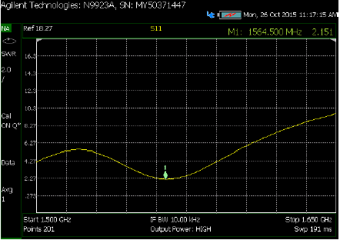
After completion of return loss test I was able to conclude that the fabricated antenna is not reflecting power in great quantity which means great loss and because of this massive power in not being radiated.
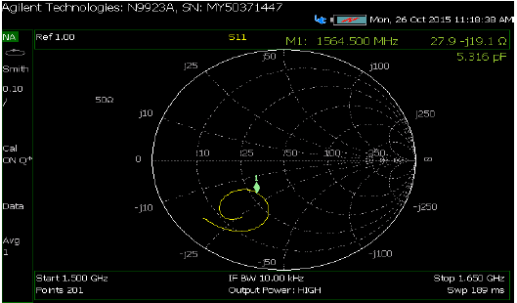
On last test when impedance is matched with frequency it reveals that the antenna is poorly matched. Because at resonant frequency of 27.9 the impedance appeared at 19.1. Below are the values obtained after network analyzer test was completed.
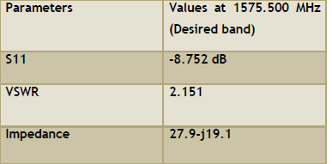
For this, I can be concluded that if VSWR of fabricated antenna were 1 then it would have performed ideally and would be at the center of smith chart.

CE 2.11
After Network testing I connected the device to raspberry pi PC to get the GPS coordinates for current location. By this real life test, it can be concluded that it can be used in real life situation. After waiting for several minutes the latitude and longitude were shown and during this process 7 satellites were found the antenna.
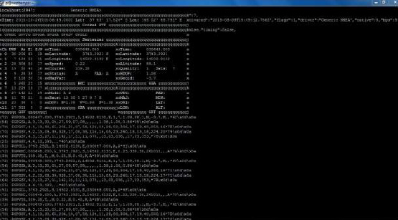

CE 2.12
After this I compiled the report and presented to my course professor for examination, a completed demo was also given to him at university labs. Upon reading the Network test results professor asked me the reason for poorly matched input impedance with resonant frequency. For this I had no idea and he gave me another week to conclude this as well.

CE 2.13
I started back tracking the whole process and found and in this process, I even made another antenna with different material to compare the results and found below mention point for poorly matched input impedance with resonant frequency.
- Poor soldering of SMA connector (Major factor)
- The placement of PAD on the PCB.
- Fabrication problem.
The major factor effecting is poor soldering and solder present on antenna. As Solder in less conductive than copper so it tends to heat up and causes the gain of antenna to decrease.
In my antenna design, I used 5 pad on top side and covered them with solder. Soldering also creates the scatter effect because of bulges on solder joints resulting in increasing return loss and degradation of antenna’s performance.
As the antenna was not well fabricated and the poorly truncated corner length contributed in matching input impedance with resonant frequency.
After finding all the Point, I presented revised report containing all the information which contributed poorly matched input impedance with resonant frequency for final review. In the end I was greatly appreciated by my professor and was awarded A grade in course.

CE 2.14
Summary
This engineering project increased my knowledge about antennas and how frequencies are being transmitted. It taught me various ways of increasing bandwidth of given antenna and how types of antennas are suitable for long ranges. During this project, I leaned the proper planning and executions are the key factors. To successfully deliver any project one has to execute in an absolute manner.

