# CAREER EPISODE 1

## INTRODUCTION:

|  |  |
| --- | --- |
| Time duration |  |
| Location |  |
| Organization |  |
| Project |  |
| Position |  |
| Project Supervisor |  |
| Project submitted to |  |

This career episode is about my project named **“Vehicle tracking and accident reporting using GSM & GPS technology” in** this career episode. This project was carried out and submitted during second year as course requirementin **Electronic and Communication Engineering** in **BTL Institute of Technology, Bangalore, India** from ……………..to ………………

## CE 1.1

The project was done during the graduate course in Electronic and Communication Engineering in ­­­­­­­­­­­­­­­­­­­_____________________. The project was carried individually under the supervision of wireless communication professor as semester project.

## BACKGROUND:

## CE 1.2

This project was completed in second year of my bachelor degree program, during my studies I learned the basics of Electronics and wireless communication and by doing this project my vision was broadened which helped in my next years of study and because of that was able to complete this project. This was the first time I was designing any system, which included electronics and communication. For the execution of project, I learned and researched a lot about Microcontroller, Embedded system and lastly GSM technology. In present the car theft incident have increased a lot and majority of public are installing GPS tracker in the vehicle. Therefore I decided if I implement Accident reporting in this technology it will help save life by reducing the amount of time it takes to report incident also while reporting incident exact location of accident will be send so that ambulances and other lifesaving department can reach exact location on time and easily by knowing the location.

## CE 1.3

This project aim was to identify and report location and time of accident happened in while driving vehicle.

This was designed to report immediately when accident occur, so by doing this emergency services or anyone can get instant update about accident and exact GPS coordinate of accidents.

By sending GPS coordinate to Emergency services it will reduce the time to locate the position of accident and in some cases when accidents occur in remote location and the people involved in accidents cannot report by themselves it will save their lives by automatically reporting and sending GPS coordinates.

## CE 1.4

This project was completely designed by me and for guidance I referred to my wireless communication professor,

Fig: Organisational Structure

## CE 1.5

The project was divided into two parts, so that I can focus better and by dividing in two parts it made me more focused and because of this I was able to complete project,

* Vehicle monitoring and real time tracking

It is an electronic device that is fitted in vehicle to track it location. For this purpose GPS was used and its was connected to microcontroller. The microcontroller process the recived GPS coodiante as per defined action.

* Indication using GSM module

At the time of impact the microcontroller sends the GPS coordinate to GSM module which sends messages usign GSM network to defined energency services or anyone. Message sent by microcontroller contains the latitude and longitude of accident spot.

**PERSONAL ENGINEERING ACTIVITY**

**CE 1.6**

As project owner I had to do design and implement the idea into real thing and for that I started doing research work and for this I contacted my university profesor and internet. First I prepared the block diagram, secondly after discussion with my course professor I prepared the circuit diagram and lastly the algorithm for the entire system.

**CE 1.7**

I built block diagram for the Project and got it reviewed from Project supervisor and by preparing block diagram it helped me implementing the project as everything was clear now. By this way I was bale to built the Project one block at time and in the end intergrated all the module together.

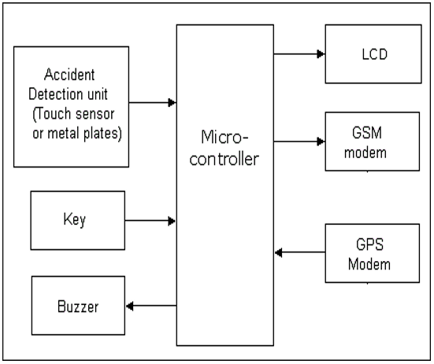

Fig: Block Digram of the Project

When an accidnet happen, it triggers the Piezo electric plates installed in accident detection unit which send signal to microcontroller, at same time microcontroller process the data and recevies the latitude and lontitude from GPS and after that it sending signal to GSM module to send text message.

**CE 1.7**

For GPS recvier I had to connect external antenna so that GPS Module can send/receive from satellites. The selection of crystal oscillator was a tough job. I incorporated multiple Crystal Oscillators but didn’t got the required results. After some discussion with the project I implied LVC1GX04 Crystal oscillator & when it was is connected to GPS module it produced highly stable clock for GPS signal to be generated. Dual antennas were used with Pre-amplifer buit in so that signal are amplified and then send to GPS Module for processing. LCD was then conneted to system so that speed and Location of vehicle can be seen on it.

**CE 1.8**

For Indication I used LED & IR sensor together which triggeres when the vehicle collide and in order for these work correctly these are placed at multpile location on front, back and sides of car. Basic Principle is when any object is close to IR sensor the light emiited from LED will bounce back and IR sensor will identify this light and signal is generated which is fed to op-amp which generates high signal. This high signal is used for identification purpose when vehicle was in collision.

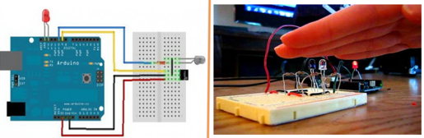

**CE 1.9**

In selecting proper microcontroller I went through some really hard time. I tested ATMEL & Samsung microcontrollers but they were not interacting with the system logically due to fewer functions. I did my research & for integrating all components, I used AT89S52 microcontroller because it was highly reliable and consumed very less power. All the indicator sensor, GSM module and GPS modules were connected to microcontroller. Microcontroller receives the input for all modules and then process according to specific algorithm. Multi-output Power was connected to entire system as it provided 5v and 12v.

## CE 1.10

For sending message of I used GSM Module with GSM SIM inserted in its slot. For sending messages I used AT commands to configure the GSM module so that it can sends messages to a fixed Number stored in the phonebook memory. I Used Below mention commands to configure GSM modem to send Messages

AT+CMGS="+92NUMBER" <ENTER>

The modem will reply with: “>” it means now text message can be send using the <CTRL>-<Z> key combination:

Vehicle accident happened at Latitude 33.71007 Longitude 73.15655 need immediate HELP<CTRL-Z>

When message is sent the modem reply with message ID to confirm that message is sent

Complete circuit diagram is shown below for the project.



## CE 1.11

During project implementation I had to find a solution in which GPS and GSM modem can communicate to microcontroller, a lot of data was lost in communication but I later found out that the baud rate was inappropriate and need to be defined to every module according to the specification so I started by 1200 bits per second and gradually increased the baud rate and found that at 4800 bits per seconds the GPS and GSM modem communicate fine with microcontroller

## CE 1.12

Configuring AT commands was challenge as these consist of short text letter which are combined to produce commands for different operation such as sending text message. By trying different combination of short letter I created the desired commands thorough which I was able to send text message to fixed number

**CE 1.13**

The advantages of this project are:

1. A low cost solution for automobile tracking
2. In car theft cases it is very useful as exact location could be easily identified.
3. In remote location emergency services can be alerted about accident and victims can be treated immediately.

The only **restrictions** of this project

1. Accident occurs in an area where there is no GSM Coverage or Signal get blocked in tunnels or mountains.

## CE 1.14

Summary

This engineering academic project boosted my knowledge about GSM network and embedded systems, while doing this project my goal was to design a system which is low cost, precise and automatically triggers indication when required. By doing this project I learned how to do research and planning work for execution of project.